Milesight-Troubleshooting
How to identify black screen and no image issues

IPC web page preview black screen without image problem is a relatively common problem, mainly including the following situations:
Before troubleshooting, it is suggested to upgrade camera’s firmware to latest version. You can download the firmware on Milesight's website or update it online on the maintenance interface.
Firmware Download|The Latest Innovation|Milesight

Judging from the black screen problems encountered so far, there are generally two main reasons for the black screen of the IPC web page preview.

Software-related
Including software bugs, software configuration, etc.;

Ⅰ.IPC webpage preview black screen and the IPC icon on the interface
The reason for this phenomenon is:
Video streams maximum connection limit, you can disconnect several video streams (such as disconnect NVR, CMS, or exit other web page preview) can view Online User to see what IP access this IPC, and try to disconnect or limit its access.You can also adjust the video stream while connecting limits
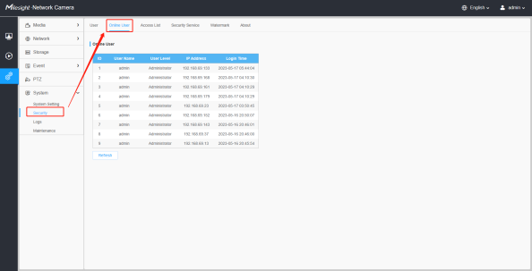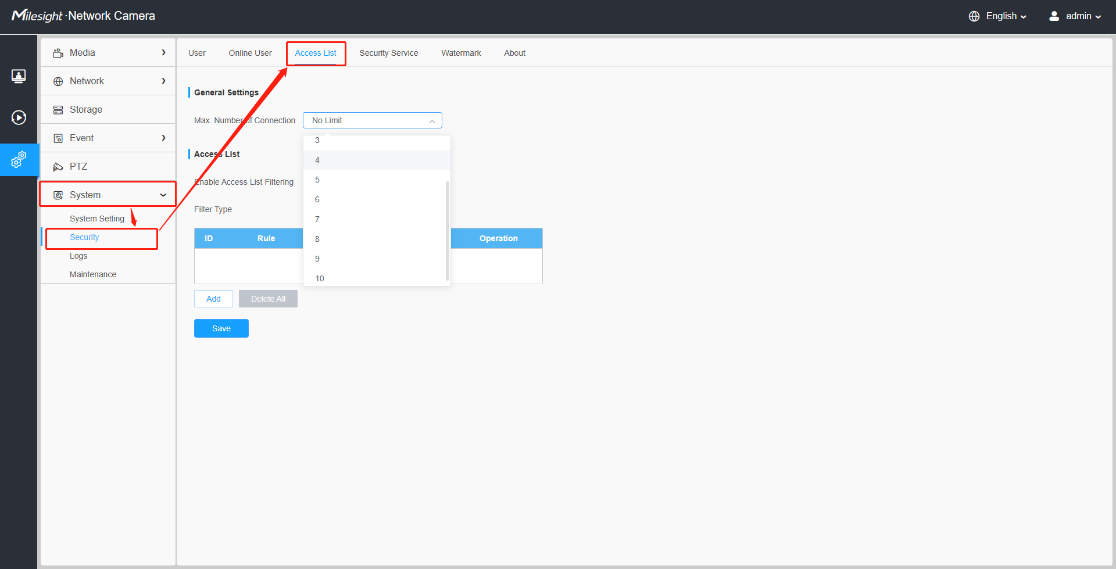
Note: The maximum number of simultaneous connections of the video stream refers to the number of RTSP streams, not the number of login points. For example, the primary and secondary streams of NVR, which indicates that two video streams have been occupied.

Ⅱ.IPC webpage preview black screen but can display coding information
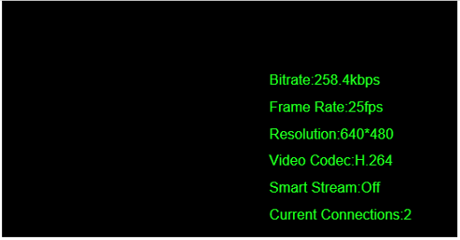
The reason for this phenomenon is:
- If the preview interface can see that the coding data displays normally (the frame rate can fluctuate normally; or try to open the OSD to see whether the display is normal), it may be a problem with setting the image parameters.
Such as too short exposure time in the low illumination environment at night, which makes the image darkness: then try to view the image setting parameters and adjust them:
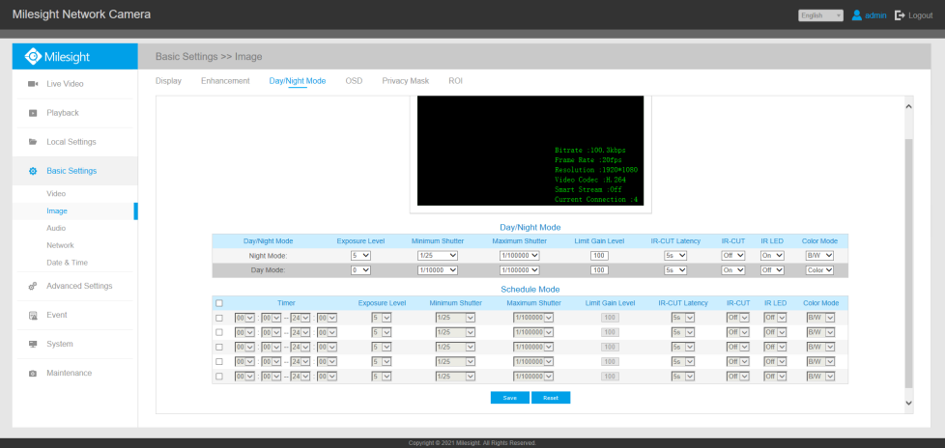
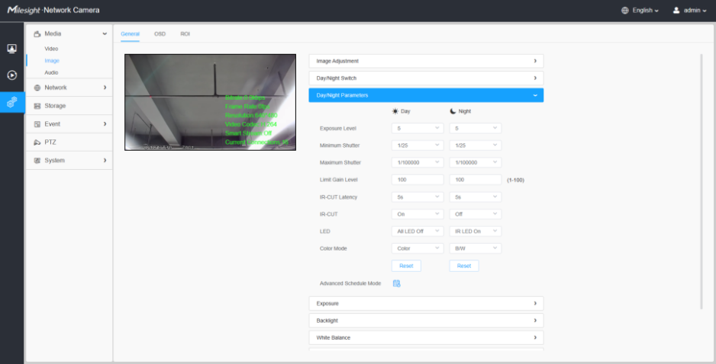
- If you can see the encoding data display on the preview interface, but the rate and other data remain unchanged, it may also be caused by hardware problems, especially for PTZ series and other AF lenses, it may be that the normal preview cannot be previewed due to halo problems.

Ⅲ.Web preview the black screen and prompt " Failed to connect video stream, please try again later!”
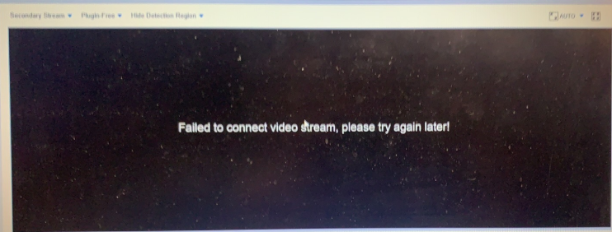
The reasons for this problem are as follows:
- There are too many video stream connections, you can disconnect several video streams (such as disconnect NVR, CMS, or exit other web page preview first).
You can view Online User to see which IP access this IPC, and try to disconnect or limit its access.
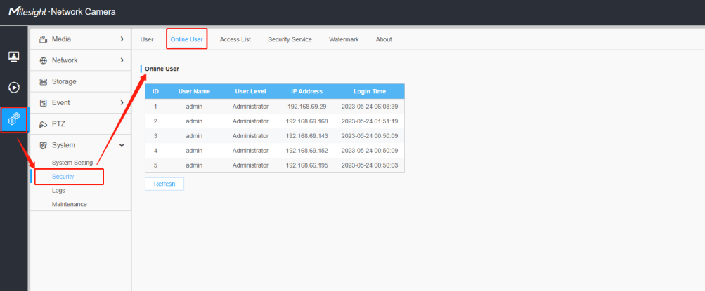
- Unstable network connection, slow network speed or network interruption may lead to the failure to connect to the video stream.
- Problems such as equipment failure, equipment offline, and equipment IP occupation may cause the video stream to fail to connect.
- Firewall reasons, the firewall may restrict access to some ports, causing the failure to connect to video streams.
- Encoding format is not supported: the encoding format of the device output does not match your computer, resulting in a failure to connect to video streams.
You can try to adjust from the perspective of the above points.

Ⅳ.Web preview the black screen and prompt " Failed to display. Please set a lower resolution or select sub stream to display!”
Note:In no plug-in mode, when the main video stream is set to 3MP and above resolution, the playback failure is prompted.
- It is recommended to reduce the resolution appropriately or use the IE plug-in mode to preview.
- Sometimes the browser-related security settings may also cause the IPC web page to fail to preview or preview a black screen. For example, from a very old image to the latest version, this problem may occur. Generally, updating the plug-in and clearing the cache can solve it.

Ⅴ.Web preview the black screen and prompt "Connections already exceed the limit, Please try again later."
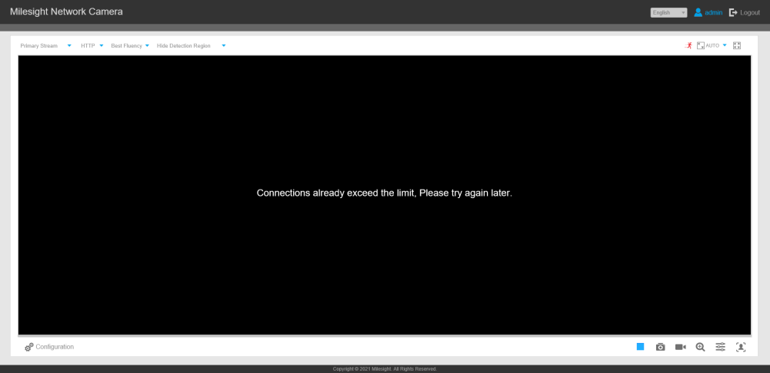
If the number of IPC video stream connections has reached the preset maximum number of simultaneous connections, the IPC page preview black screen, then the page may prompt "Connections already exceed the limit, Please try again later." or " Failed to connect video stream, please try again later!” Or the black screen and the IPC icon will appear (usually, the IPC icon appears directly after a while), as follows:
In this case, you can view it in IPC Security-> Access List:
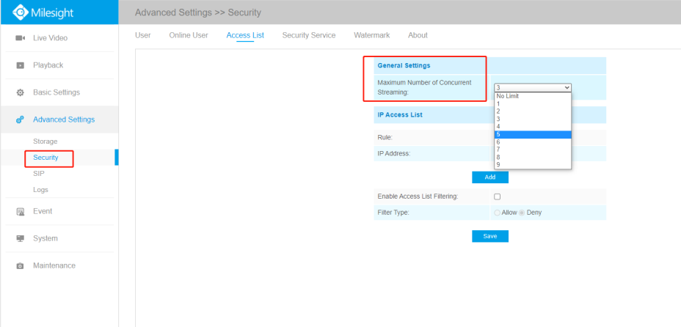

Ⅵ.The IPC cannot be preview normally after the remote mapping of the external network;
If you cannot preview the IPC after remote mapping, it could be that RTSP port is not mapped properly. For Milesight IPC, in addition to mapping HTTP port (default 80), also need to map RTSP port (default 554), otherwise only access to the IPC without preview (performance is the preview black screen), as follows:
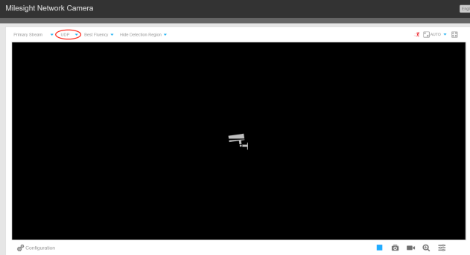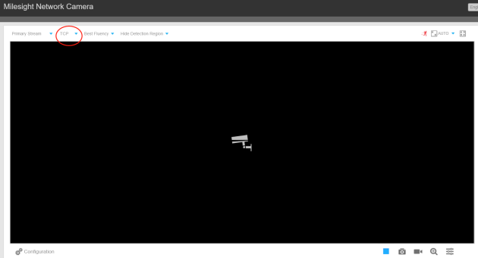
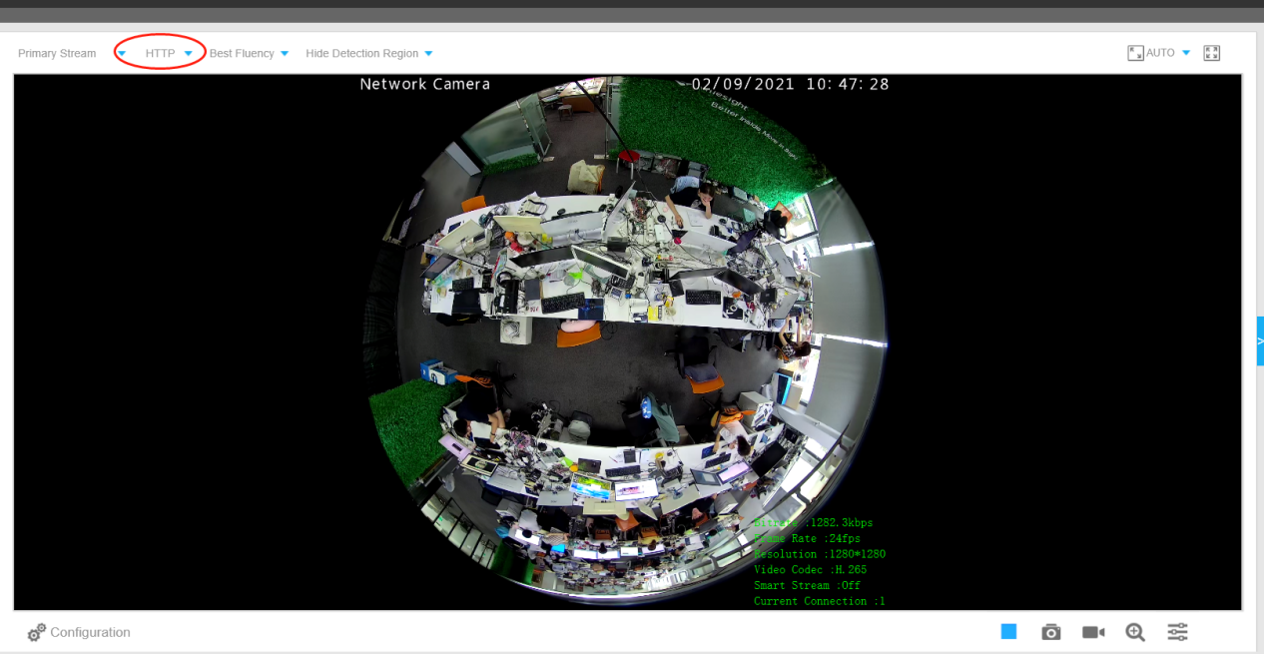
When the RTSP port is not mapped, only the UDP / TCP protocol cannot play properly, and the HTTP is not affected. Currently, IE browser / Chrome / Firefox and other browser broadcast through HTTP by default; however, Chrome / Firefox browser uses plug-free mode, only HTTP play; while IE browser has HTTP / UDP / TCP three options, it is recommended to use IE switch HTTP / UDP / TCP test.
In addition to the remote mapping RTSP port not mapped, the preview failure may also be due to the computer firewall not opening the specified port or the antivirus software block.
So you can try turning off the firewall and the antivirus software first.

Hardware-related
Including Wire connection problem, sensor board or motherboard damage, the details can be found in the following map:

Ⅰ.IPC webpage preview black screen without any icon or coding information on the interface
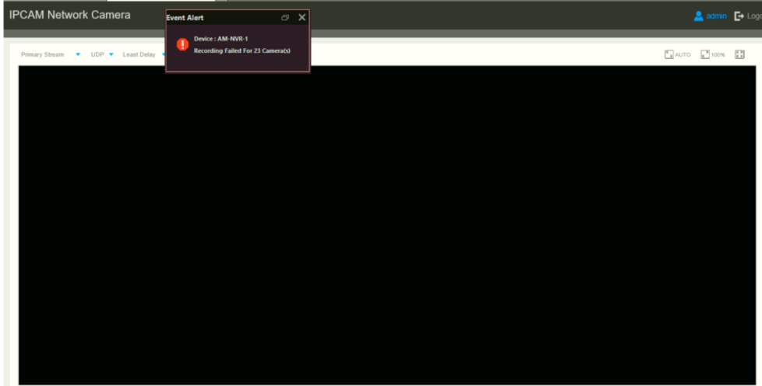
If you encounter this phenomenon:
it is recommended that you first replace IE / Chrome / Firefox / Edge and other browser for playback preview;
If there is still no image, the high probability is a hardware problem,it is recommended that you reset the hardware of the device first;
https://support.milesight.com/support/solutions/articles/69000643407-how-to-reset-hardware

If you still can't preview the screen after hardware reset, it is recommended to disassemble the camera and check the wiring problems between PCBA boards to ensure that the wiring is not loose, and confirm that there is a phenomenon of poor contact, seams or breaks;If you have certain conditions, you can try to do a replacement test of the same component.
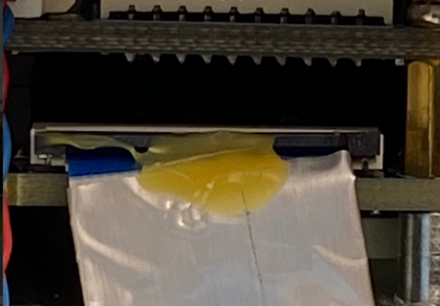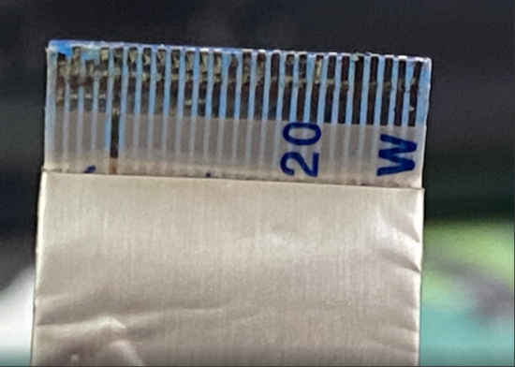
Also, you can check the status of the sensor board.
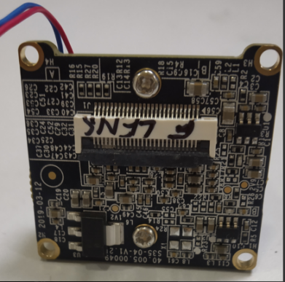
If the device returns to normal after the unplugging and replacement tests, or if the device problem does not improve, please contact your sales or Milesight Support team for further troubleshooting or RMA processing.

The above are all the phenomena and troubleshooting processes of the black screen without image problem that you may encounter at present.
If you are still unable to restore the playback preview of the device after checking any of the above problems, please contact Milesight for technical support, and we will help you for the first thing after receiving the message.
Submit a ticket : Support (milesight.com)

---------------------------------------------------------------END---------------------------------------------------------------------

