Milesight-Troubleshooting

VMS Enterprise Event Rules

to PoE NVR

VMS Version | V1.9.0.0-r2 | Update | 2023.9.8

Ⅰ. Introduction
Event rules are used to associate events and actions. Milesight VMS Enterprise supports rich events, multiple actions and alarm modes, which you can combine freely and configure as your need. Every event can be set to trigger many kinds of actions at the same time. Also, every event can be set to trigger different actions in different time periods. After configuring the event rules, when an event is detected, it can promptly remind or automatically trigger actions according to your settings. In this case, focusing on events becomes easier and you won’t miss the events you care about.

By default, some rules have been automatically created for you in the system. These rules are used to notify the abnormalities that may occur in the system. If an event is detected, you will receive a notification in the Notifications panel. It is strongly recommended to keep them. You can also adjust them as needed.
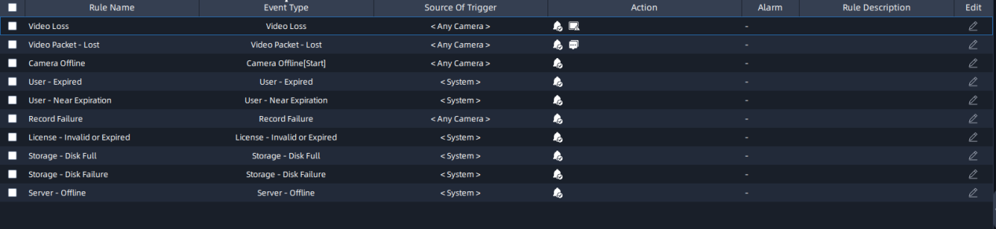

Ⅱ. How to set an event rule
If you’re not an owner or administration, make sure you have permission for event rule settings.
2.1 Add an event rule
Step 1: Go to “Event & Alarm” -> “Event Configuration” -> “ Event Rules”.

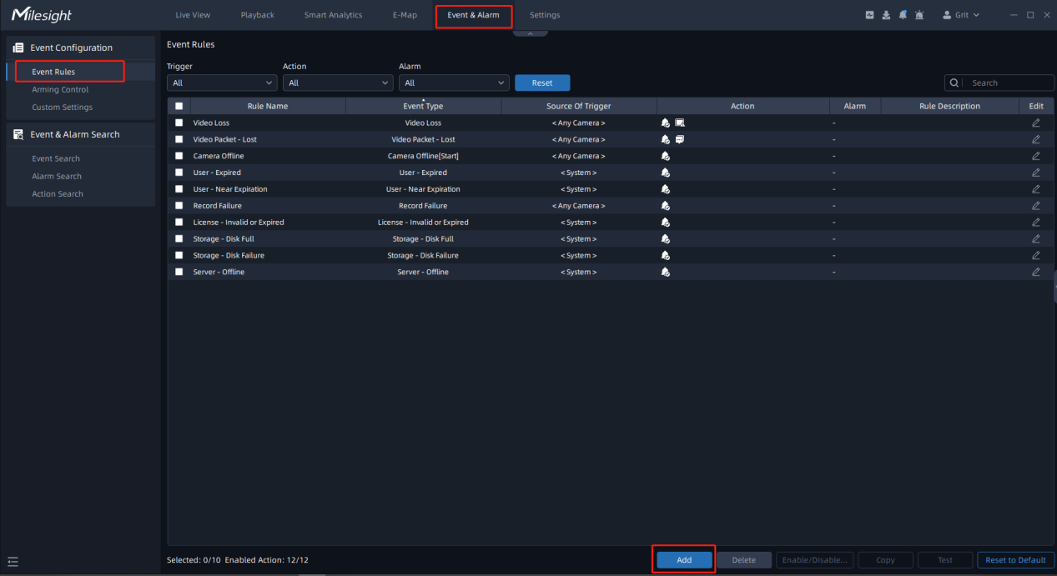
Step 2: Click “Add”. Set trigger, schedule and action, then click “Save”.
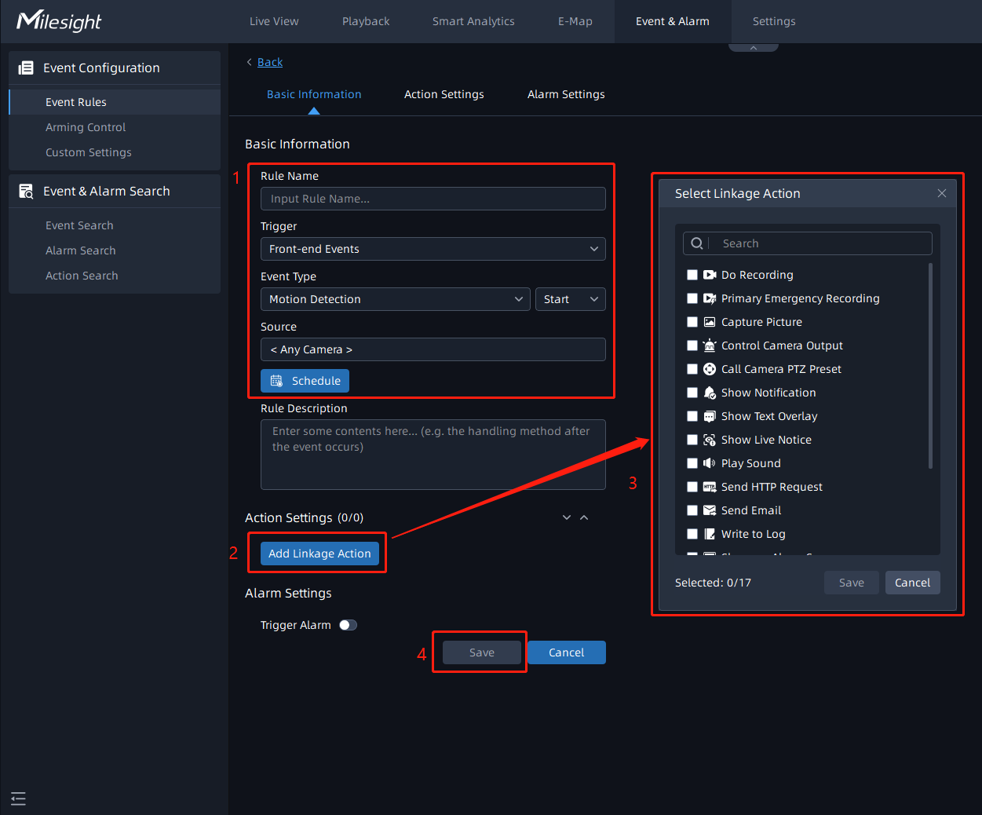
There are many kinds of events and actions. Different events or actions have corresponding settings. Here you can check the below table to know more about them.
- Trigger
Parameter | Function Introduction
Front-end Events | Front-end Motion Detection: When cameras detect object motion, the event will be triggered. The event trigger has two statuses including Start and Stop, you can set different camera sources and schedules for different states. The page is as below:  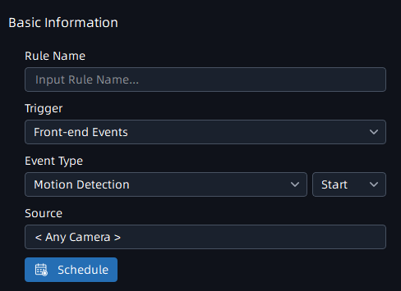  Note: Enable the Motion Detection of Milesight camera before using the function.
Front-end Audio Alarm: The event trigger setting page is the same as the Front-end Motion Detection setting page.
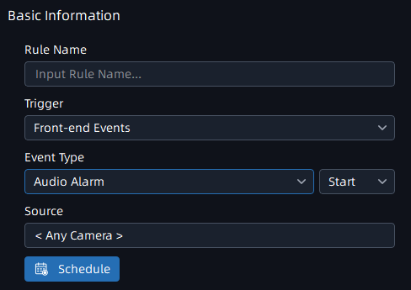
Note: Enable the Audio Alarm of Milesight camera before using the function.
Front-end External Input Alarm: The event trigger page is as below. If the selected camera has multiple alarm interfaces, you can choose a type of Input ID. The default Input ID is Auto Detect.
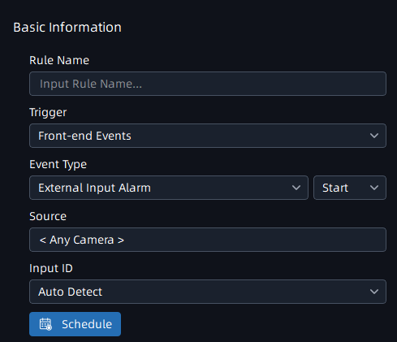
Note: Enable the External Input Alarm of Milesight camera before using the function.
Front-end VCA: You can set different camera sources, schedules and VCA event types here. The page is as below:
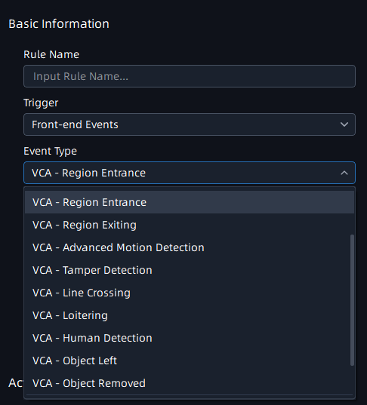
Note: Enable the VCA event of Milesight camera before using the function.
People Counting: Here you can set the trigger rule of two modes, including People Counting and Regional People Counting. When the number of people detected exceeds the threshold you set, the event will be triggered. The page is as below:
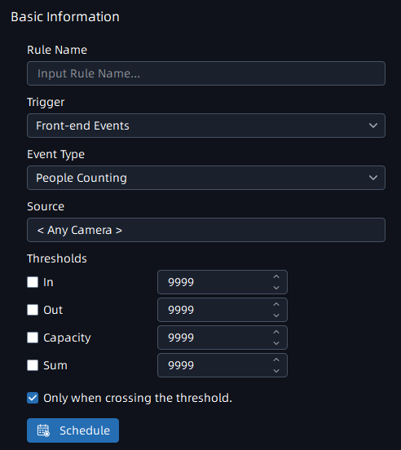
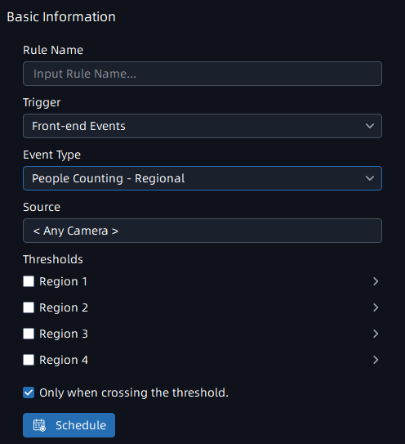
Note:
• Enable the People Counting event of Milesight camera before using the function.
• Here you can enable the option in the image below, the alarm will only be triggered if the threshold is exceeded, otherwise it will be triggered every time the value changes.
Smart Analytics Events | Analytics: Here you can set Smart Analytics Events trigger rule of five modes, including Motion Detection, Region Entrance, Region Exiting, Line Crossing and Loitering. You can set different camera sources and schedules here. The page is as below:  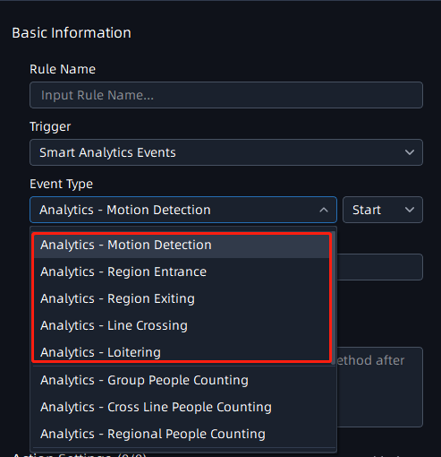
ANPR: Here you can set ANPR trigger rule of five modes, including Vehicle Detection, Visitor Detection, Speed Detection, Congestion Detection and Retrograde Detection.
The VMS system will trigger alarm actions according to the configuration rules. The page is as below:
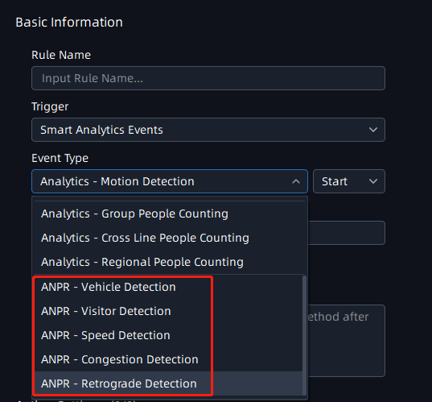
AI Box Analytics Events | Behavior - Fall Detection: You can set Fall Detection trigger rule for selected cameras. Once the selected cameras detect Fall Detection, the event rule will be triggered. Here is a video about Fall Detection：  https://www.youtube.com/watch?v=g8pWIm4tuLI  The page is as below:  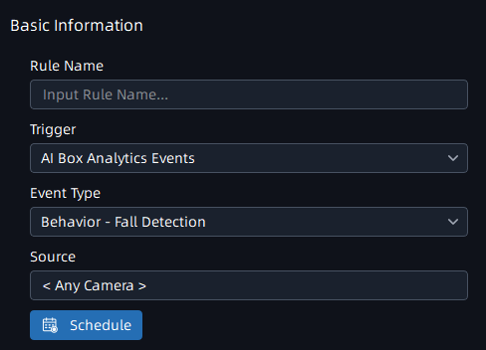
IOT Sensor Events | Here you can set IoT Sensor Events trigger rule of five modes, including Occupancy, Door Sensor, Smoke Detector, Electronic Switch and Smart Button. You can set different sensor sources and schedules here. Here is a video about integration between our VMS Enterprise and Milesight IoT gateways and sensors.  https://www.youtube.com/watch?v=MkjlRm_xdfE  The page is as below:  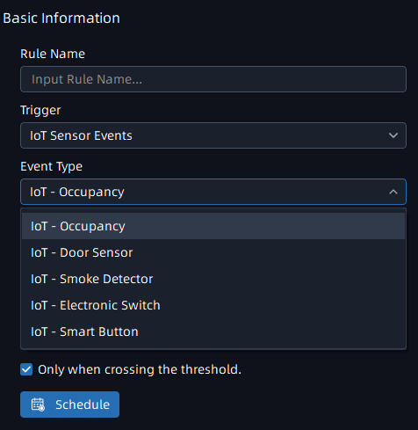
Connection Issue | Video Loss: You can set Video Loss trigger rule for selected cameras. Once the selected cameras are disconnected beyond the set time, the event rule will be triggered.  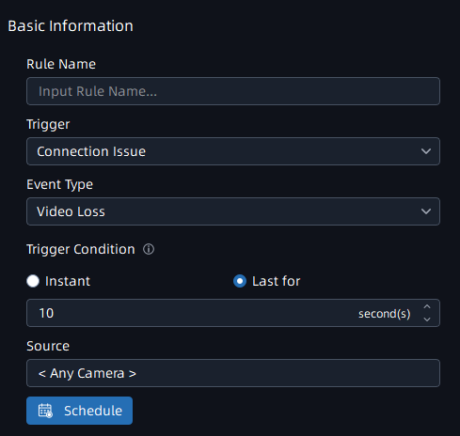
Video Packet: Here you set the event rule as Video Packet Lost or Video Packet Resume.
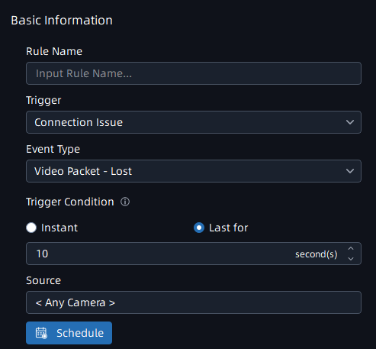
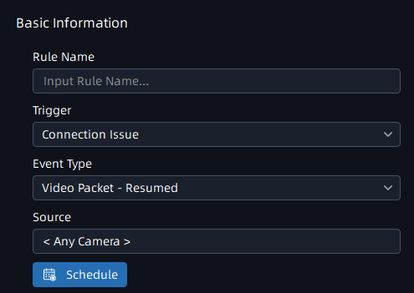
The Video Packet Lost event will be triggered if the VMS system detects the video packet is lost for more than the set time.
The Video Packet Resumed event will be triggered if the VMS system detects the video packet is resumed in the last 1 minute.
Camera Offline: It will trigger an alarm whether the camera is offline or online.
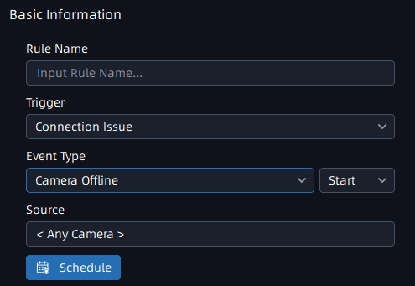
System Events | Export/Backup Finished: After setting the event rule, the event is triggered when the VMS system finishes data backup or export, like recording video export, system and server configuration export, etc. The page is as below:  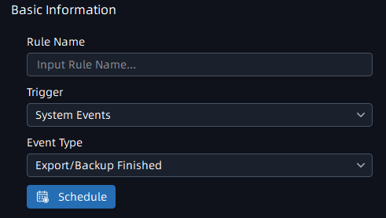
User Issue: Here You can set five types of User trigger rule, including Expired, Near Expiration, Login Succeeded, Login Failed and Logout. The page is as below:
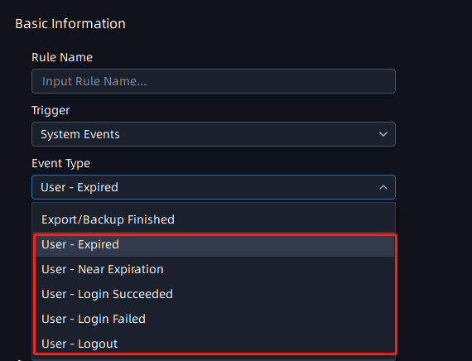
Server Events | Record Failure: You can set a schedule for the selected cameras, if the selected cameras record fails, then the event will be triggered.  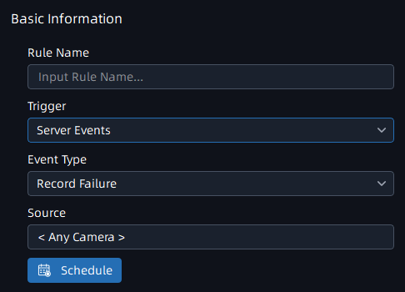
License Issue: You can set three types of License Issue trigger rules, including Invalid, Expired and Near Expiration. You can set duration for Near Expiration Date if your license is close to expiring, then the event will be triggered duration days before Expiration Date.
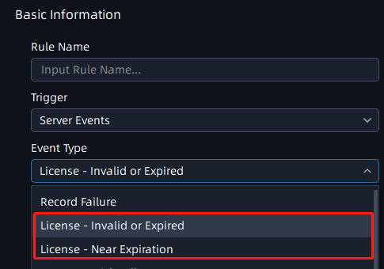
Storage Issue: After setting the event rule, the event will be triggered if the VMS system detects Storage Issue. There are three types of Storage Issue, including Disk Full, Disk Load too High and Disk Failure.
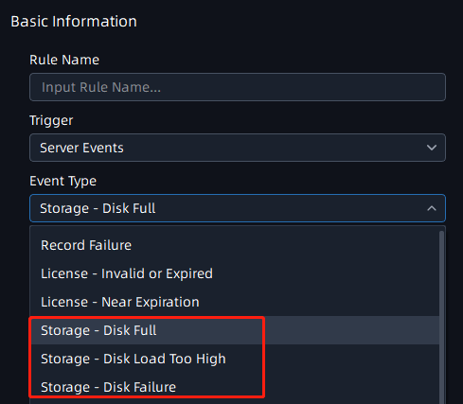
Note: In the settings of the Disk Full event, the user can choose to mute the alarm when the storage recycle is enabled.
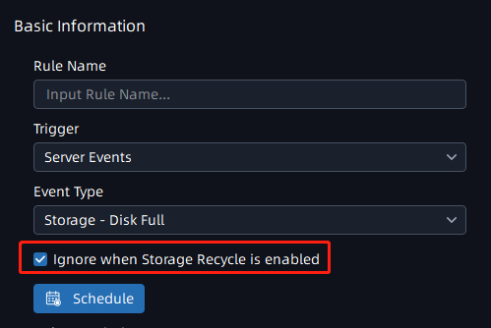
Server Issue: After setting the event rule, the event is triggered if a certain server is started, offline or conflict in the VMS system. The page is as below:
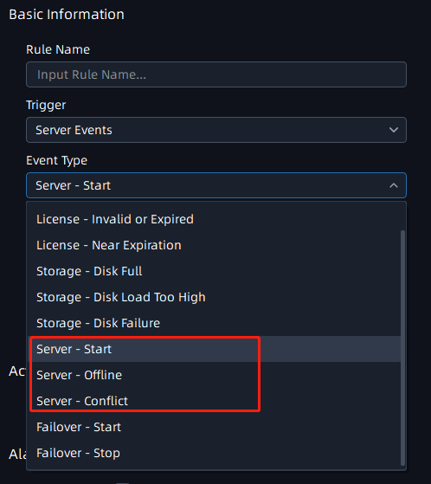
Failover: After setting the event rules, the event will be triggered if the VMS system detects Failover Start Working or Stop Working after Server Recovery.
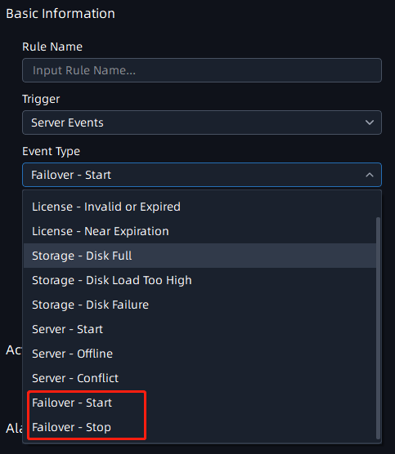
HTTP Event | HTTP Event: After setting the event rules, the HTTP event will be triggered only if there are matches in the ‘Caption’, ‘Source’, or ‘Description’ with any of the entered keywords if the VMS system receives an HTTP push from external devices. The page is as below:  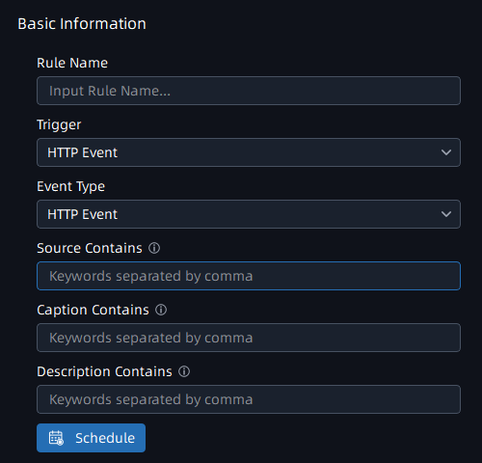  Note: If the field is empty, event will always be triggered.
Client Trigger | Client Trigger: Here you can set an trigger icon, users who will be available to use this trigger, remark and trigger schedule for selected cameras. The page is as below:  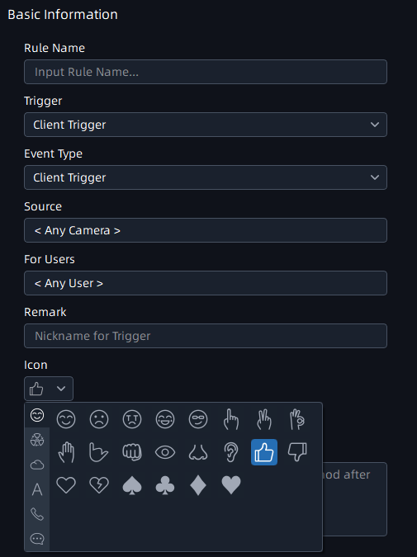  After setting the rule, selected users can see the trigger rule icon and remark in live view window of selected cameras.  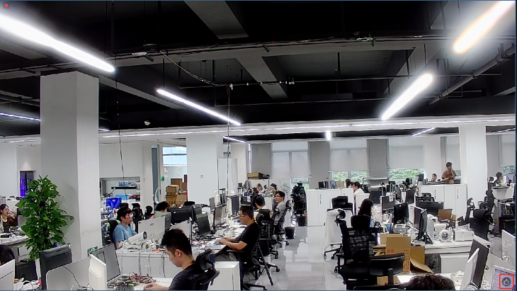  An event occurs when you click the icon.

- Action
Action | Description
Add Tag | When the Event Trigger is set to HTTP Event or Client Trigger, it supports triggering "Add Tag" to the recording. The page is as below:  ①HTTP Event:  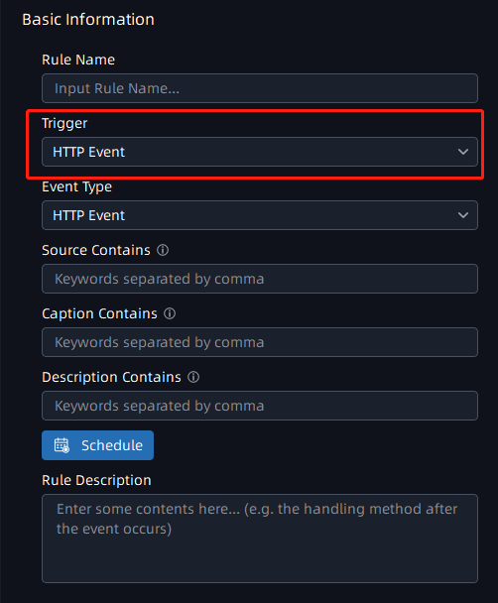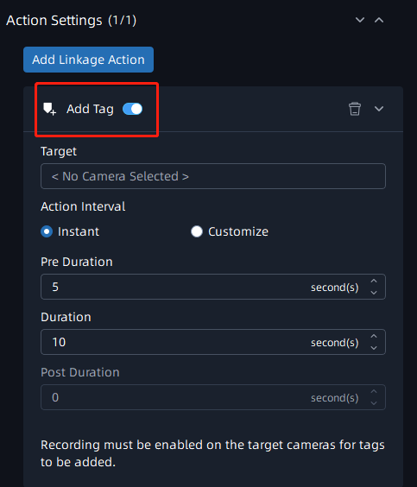  ② Client Trigger:  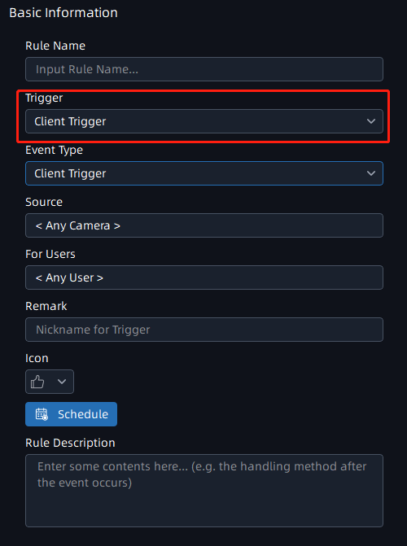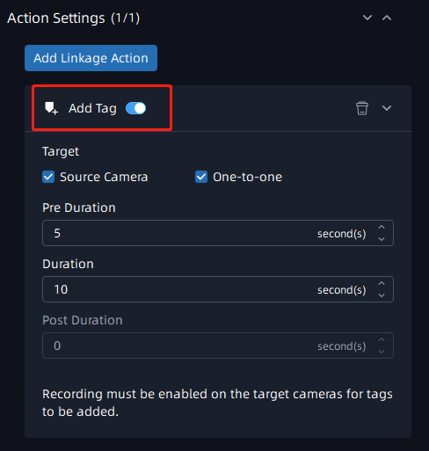  Target: You can check “Source Camera” or select cameras as needed. If you check “Source Camera”, the target cameras are the same as you select in “Source”. If you check “One-to-one”, only the camera that has an event will be triggered to do an action.  Action Interval: The time interval of triggering action.  Pre Duration: How long in advance to start adding tags.  Duration: The duration of adding a tag, within 1~3600s.  Post Duration: How long to end adding a tag after the duration.  Then users can see the tag on the timeline as shown below.  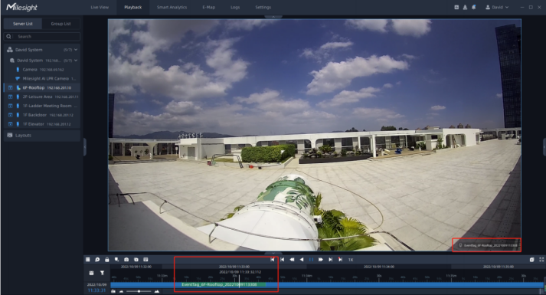
Do recording | When an event is detected, it will trigger the cameras to record. You can view the recordings in Playback interface. The page is as below:  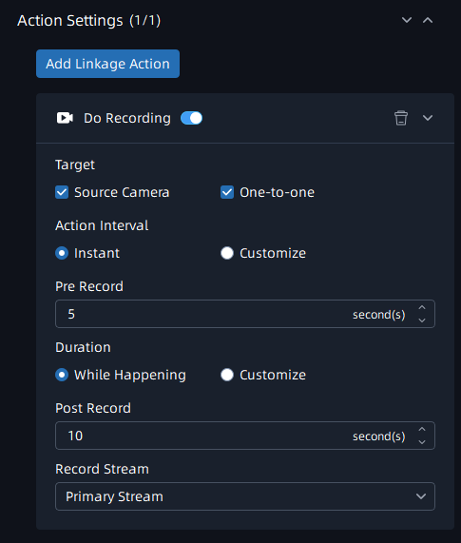  Target: You can check “Source Camera” or select cameras as needed. If you check “Source Camera”, the target cameras are the same as you select in “Source”. If you check “One-to-one”, only the camera that has an event will be triggered to do an action.  Action Interval: The time interval of triggering action.  Pre Record: How long in advance to start recording.  Duration: The duration of the recording. If you select “While Happening”, trigger actions from the occurrence of the event until the end of the event. If you select “Customize”, you can customize the duration of the trigger action.  Post Record: How long to end the recording after the duration.  Record Stream: Type of recording stream.
Primary Emergency Recording | When an event is detected, it will trigger the cameras to record the primary stream. The page is as below:  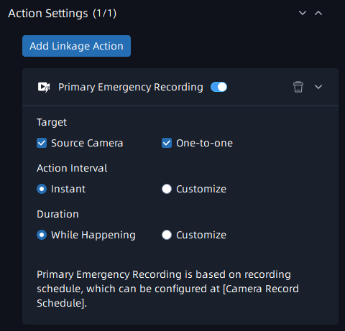  Target: You can check “Source Camera” or select cameras as needed. If you check “Source Camera”, the target cameras are the same as you select in “Source”. If you check “One-to-one”, only the camera that has an event will be triggered to do an action.  Action Interval: The time interval of triggering action.  Duration: The duration of the recording. If you select “While Happening”, trigger actions from the occurrence of the event until the end of the event. If you select “Customize”, you can customize the duration of the trigger action.  Description of Rule: Any description as your need.  Note:  - This is based on recording schedule, so continuous recording needs to be enabled. You can set it in “Settings” -> “Devices” -> “Camera Record Schedule”.  - The targeted devices that are recording the primary stream video still continue to record primary stream video when related event is triggered.
Capture Picture | After setting the action rule, the Source Camera is allowed to trigger  snapshots on Evidence Camera. The page is as below:  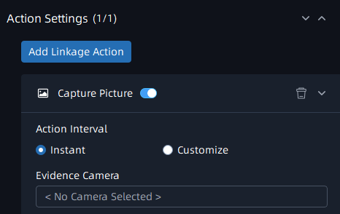  Action Interval: The time interval of triggering action.  Evidence Camera: Within 2 evidence cameras are supported.  Note: Within 2 evidence cameras are supported.
Control Camera Output | After setting the action rule, the current output status of selected target camera will change to another status according to the action setting when the corresponding event is triggered. The page is as below:  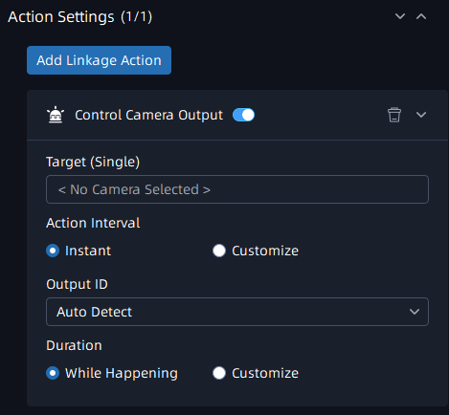  Target (Single): Only one targeted camera can be selected. If you want more cameras to perform the action, and you can copy the event rule to configure separately.  Action Interval: The time interval of triggering action.  Output ID: Select specific output interface or “Auto Detect”. If you select “Auto Detect”, system will detect output interface automatically.  Duration: The duration of the camera output status change. If you select “While Happening”, trigger actions from the occurrence of the event until the end of the event. If you select “Customize”, you can customize the duration of the trigger action.  Note: Only one targeted camera can be selected. If you want more cameras to perform the action, and you can copy the event rule to configure it separately.
Call Camera PTZ Preset | When an event is detected, it will trigger the cameras to call their PTZ Preset. The page is as below:  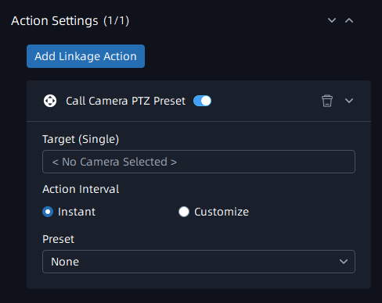  Target (Single): Select cameras as needed  Action Interval: The time interval of triggering action.  Preset: Select a preset to be called.  Note: The default target cameras only display the devices which can support PTZ function.
Show Notification | When an event is detected, it will trigger to show notification in Notifications panel. The page is as below:  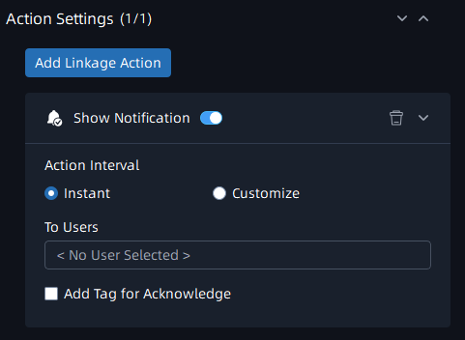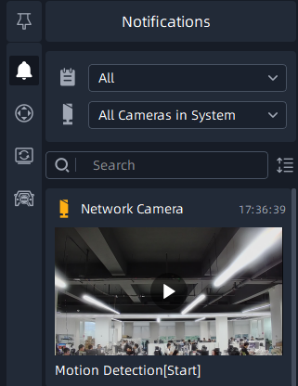  Action Interval: The time interval of triggering action  To Users: Select users in the system who will see the notification. You can click “Add tag for Acknowledgement” to tag this video.  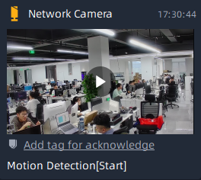  Note: Selected users must set to receive the notification in the Notification Filter, and then can see the event notification in the notifications panel.
Show Text Overlay | When an event is detected, it will trigger to show specific text in live view of the cameras. The page is as below:  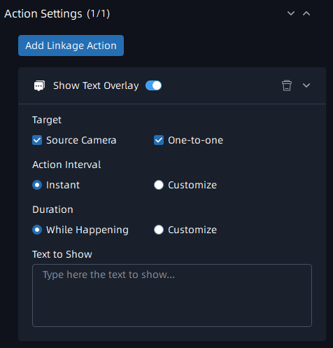  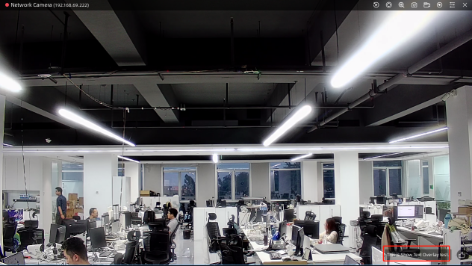  Target: You can check “Source Camera” or select cameras as needed. If you check “Source Camera”, the target cameras are the same as you select in “Source”. If you check “One-to-one”, only the camera that has an event will be triggered to do an action.  Action Interval: The time interval of triggering action.  Duration: The duration of the text display. If you select “While Happening”, trigger actions from the occurrence of the event until the end of the event. If you select “Customize”, you can customize the duration of the trigger action.  Text to Show: Type the text that you want to show.
Show Live Notice | Once the event is triggered, it will flash a frame and show the alarm icon on the Live View interface according to the setting, making monitoring more intuitive and efficient. The page is as below:  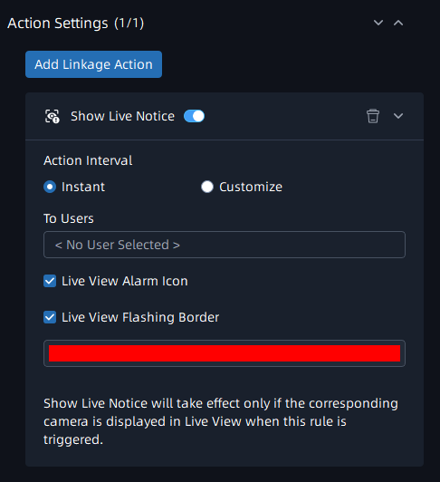  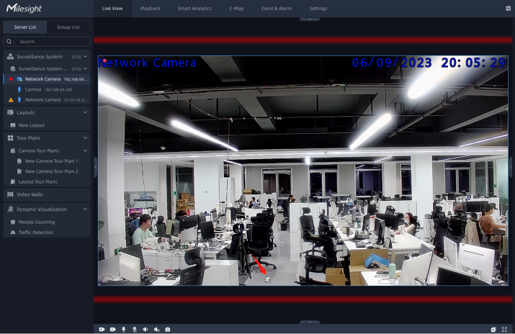  Action Interval: The time interval of triggering action.  To Users: Select users in the system who will see the notification.  Live View Alarm Icon: Enable it to show the alarm icon on the Live View interface once the event is triggered.  Live View Flashing Border: Enable it to flash a frame on the Live View interface once the event is triggered.
Play Sound | When an event is detected, it will trigger to play specific sound.The page is as below:  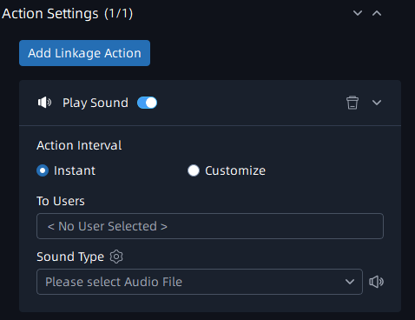  Action Interval: The time interval of triggering action.  To Users: Select users in the system who will see the notification  Sound Type: Select sound file as needed. You can click to listen to the selected sound file.  Note: The user can upload 32 audio files at most.
Send HTTP Request | After setting the action rule, the VMS system will send HTTP Request to the URL filled in the box when the corresponding event is triggered.The page is as below:  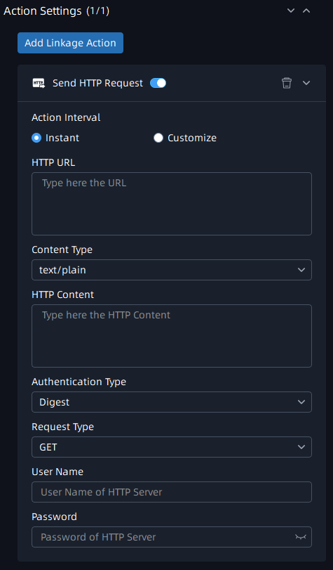  Action Interval: The time interval of triggering action.  HTTP URL: The address to receive the message like http(s)://……  Content Type: Including test/plain, test/html, application/html,  application/json, application/xml.  HTTP Content: The HTTP request content.  Authentication Type: Including Digest/None/Baic.  Request Type: Including GET/POST/PUT/DELETE.  User Name: User name of the server that receives the request.  Password: Password of the server that receives the request.  Note: The HTTP URL format can be customized, for example: http://{ip}:{port}/api/httpEvent?xxxxxx
Send Email | After setting the action rule, the VMS system will send the event emails including trigger, event source and time, etc., to the selected users and other recipients which you set when the corresponded event is triggered. The page is as below:  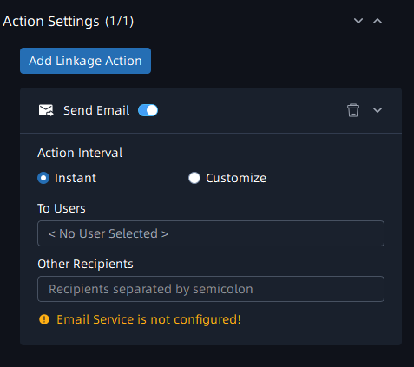  Action Interval: The time interval of triggering action  To Users: Select users in the system who will receive the email  Note: User’s email needs to be configured. You can set it in “Settings” -> “System&Servers” -> “User Settings”.  Other Recipients: Type other recipients. Multiple recipients are separated by semicolon.
Write to Log | After setting the action rule, the VMS system will write the information about event to event logs when the corresponding event is triggered. The page is as below:  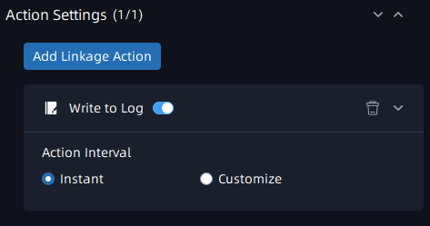  Action Interval: The time interval of triggering action.
Show on Alarm Screen | After setting the action rule, the VMS system will push the live view of camera to display on Alarm Screen while action is triggered. The page is as below:  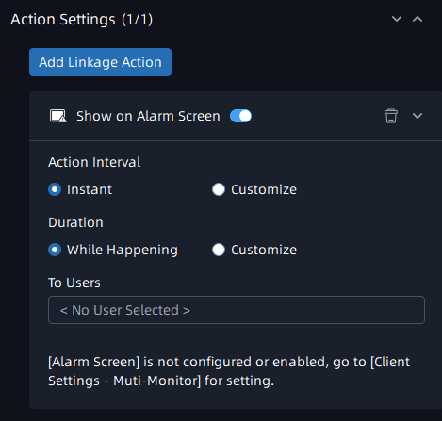  Action Interval: The time interval of triggering action.  Duration: The duration of displaying on alarm screen. If you select “While Happening”, trigger actions from the occurrence of the event until the end of the event. If you select “Customize”, you can customize the duration of the trigger action.  To Users: Select users in the system who will see this action.  Note: Alarm Screen needs to be configured, you can set it in “Settings” -> “Client Settings” -> “Multi-Monitor”.
Show on Full Screen | After setting the action rule, the VMS system will push the live view of camera to display on Full Screen while action is triggered. The page is as below:  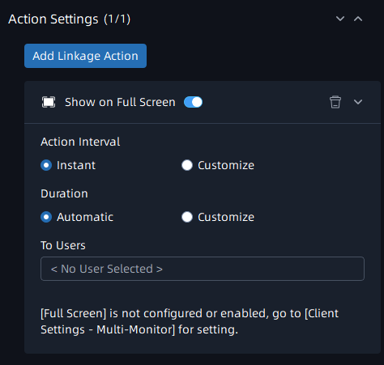  Action Interval: The time interval of triggering action.  Duration: The duration of displaying on full screen. Only one channel will be displayed on full screen at a time. When you select “Automatic”, as long as a new channel triggers this action, its live view will be pushed to display on full screen. When you select “Customize”, new channel will be pushed to display on full screen only after the previous channel that triggered the action ends.  To Users: Select users in the system who will see this action.  Note: Alarm Screen needs to be configured, you can set it in “Settings” -> “Client Settings” -> “Multi-Monitor”.
Maximize Video Window | After the action rule is set, the VMS system will maximize the live view of camera on the current video window while action is triggered. The page is as below:  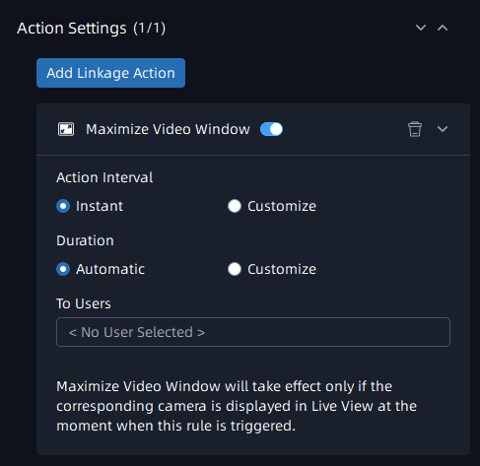  Action Interval: The time interval of triggering action.  Duration: The duration of full screen display. When you select “Customize”, if you check “Exit when duration ends”, the full screen will be automatically exited after the set duration is reached, otherwise the full screen will continue to be maintained.  To Users: Select users in the system who will see this action.  Note:  - Maximize Video Window will take effect only if the corresponding camera is displayed in Live View at the moment when the event is triggered.  - Only live view of one channel can be maximized to the current video window each time.
Send Notification to Mobile App | After the action rule is set, the VMS system will push alarm message to M-VMS Mobile App. The page is as below:  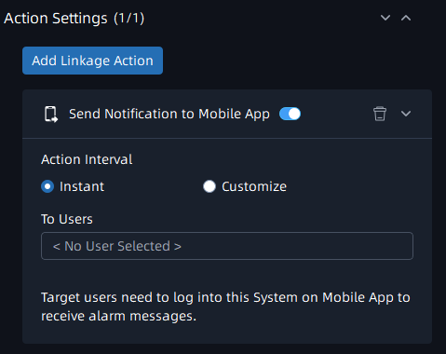  Action Interval: The time interval of triggering action.  To Users: Select users in the system who will see this action.  Note: Please make sure the version of M-VMS App is V1.0.0.2 or above.
IOT Senor Control | When an event is detected, it will trigger IOT sensor to do selected action. The page is as below:  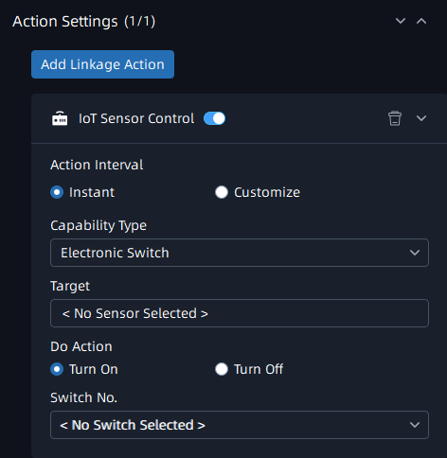  Action Interval: The time interval of triggering action.  Capability Type: Including Smoke Detector and Electronic Switch.  Target: You need to add a gateway firstly and then select sensor you added in VMS.  Do Action: Turn on or turn off Electronic Switch.  Switch No.: The Electronic Switch No.
Step 3: It is optional to enable Trigger Alarm. When you enable it, then the Alarm Data will be generated in the Alarm Center.
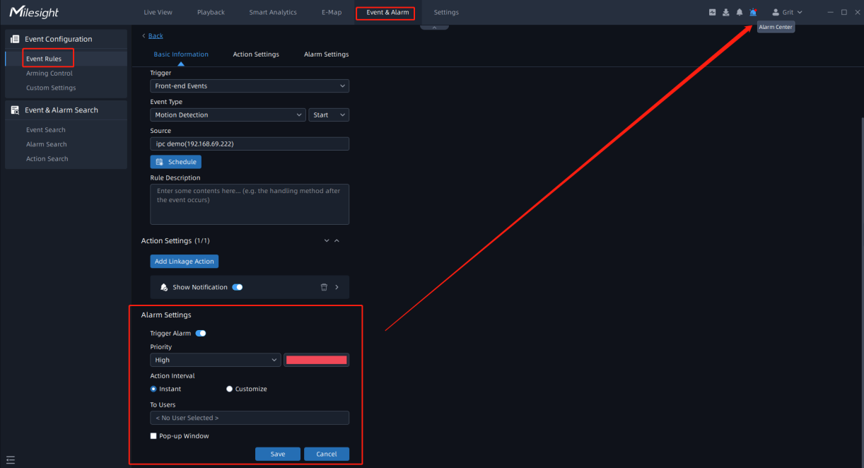
Step 4: After adding event rules, you can see them in the list.
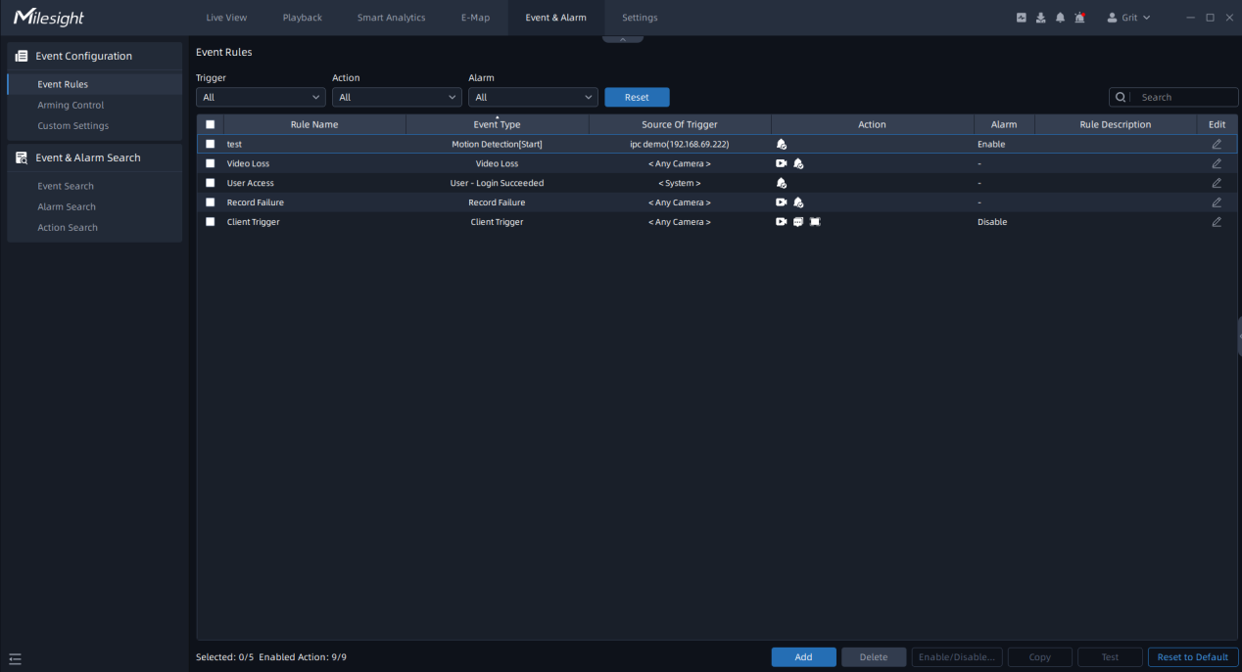
Optional: You can also edit or delete the event rules as needed.
Operation | Description
 | Edit a rule. You can adjust the parameters of trigger, schedule or action as needed.
 | Click a rule in the list that you want to remove, click “delete”, and click “Yes” in the pop-up window. The rule will be removed from the list.
 | Enable or disable the event action.
 | Copy the selected event rule.
 | System will simulate the triggering if the selected rules.
 | Reset to the default rules.

Ⅲ. Example
- Setting
Set the following event rules in the system.
- From 11 a.m. to 12 a.m., when a motion event is detected in “ipc demo”, do recording, show notification and send email to selected user.
- From 10 a.m. to 11 a.m., when a motion event is detected in “ipc demo”, call “ptz demo” preset and show a notification.
- When any camera in the system has video loss, show a notification.
- When any user logs in to the system, shows a notification.
- When any camera in the system fails to record, show a notification.
- Add an icon to each camera. After clicking the icon, show text in live view of the camera and push the live view of the camera to display on full screen.
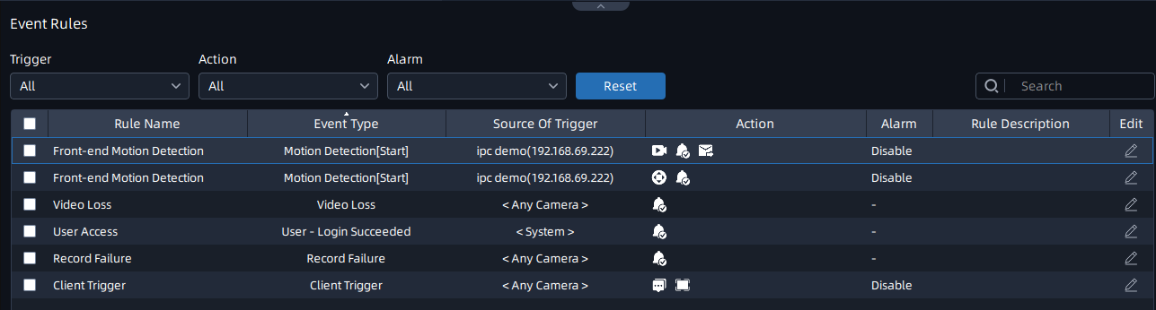
- Result
- From 11 a.m. to 12 a.m., when a motion event is detected in “ipc demo”, a notification will be shown in Notifications panel. Selected user will receive an email. And you can view the recording in Playback interface.
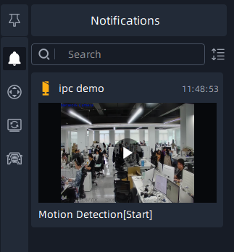
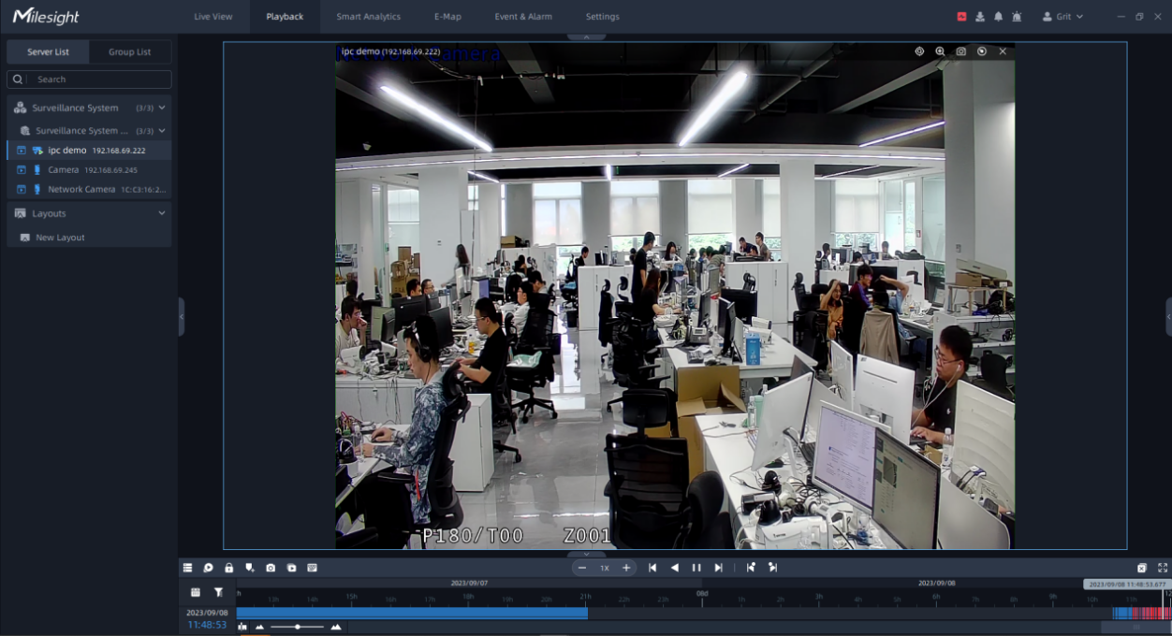
- From 10 a.m. to 11 a.m., when a motion event is detected in “ipc demo”, call “ptz demo” preset and a notification will be shown in Notifications panel.
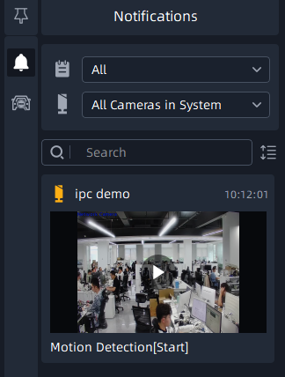
- When a camera in the system has video loss, a notification will be shown in Notifications panel.
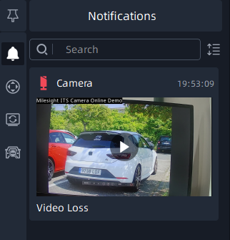
- When a user logs in to the system, a notification will be shown in Notifications panel.
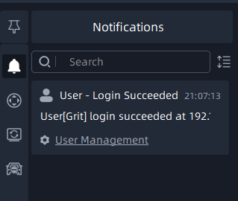
- When a camera in the system fails to record, a notification will be shown in Notifications panel.
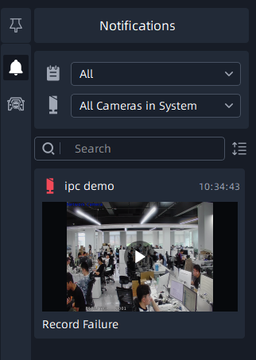
- After clicking the icon, the text will be shown in the live view of the camera. And live view will be displayed on full screen.
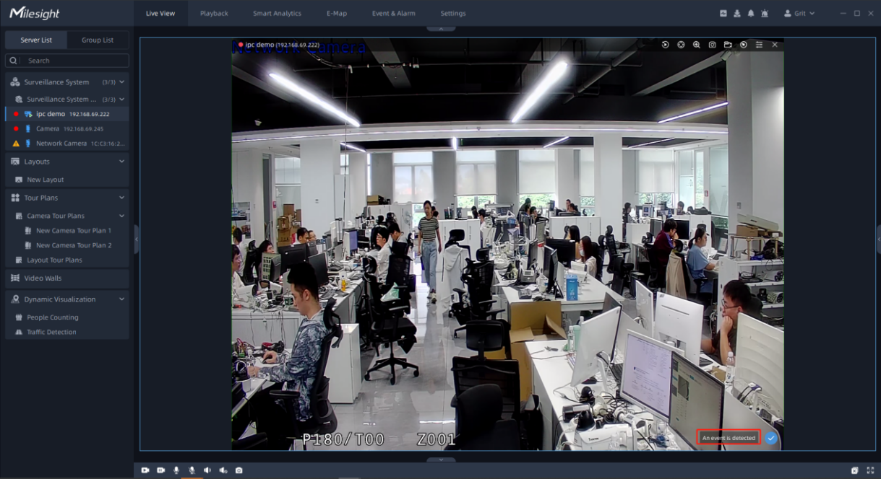
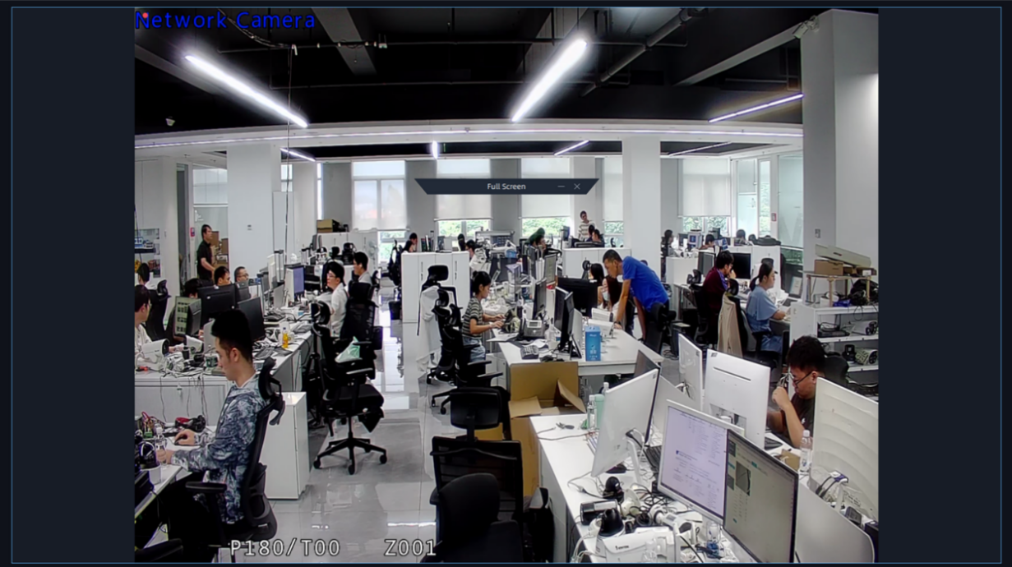
All events will be recorded, you can view them in Event & Alarm Search interface.
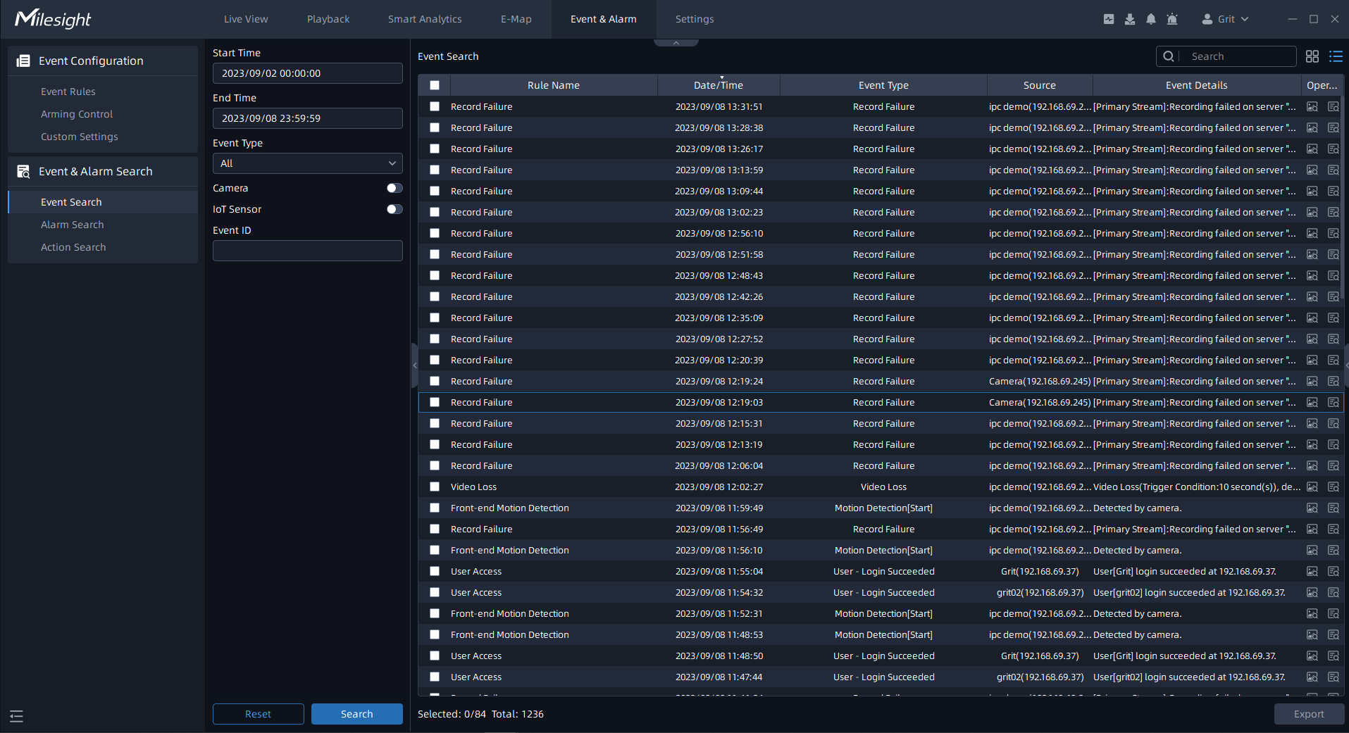
-END-

