Milesight-Troubleshooting

Common causes of LPR data push failures to Milesight NVR

Version | V1.0 | Update | 2023.9.13

Description
This document introduces common problems and reasons why LPR fails to push license plate data to Milesight NVR, including the following aspects:
- Setting the correct LPR message post mode
- Checking the firewall of the network environment
- TCP connections limit
- Configuring the LPR data post port
- Version defects

Check preparation
Here are some notes you should notice before using ANPR function.
- It is recommended that you upgrade the firmware to the latest version. You can download the firmware on the Milesight official website or upgrade it online
Firmware Download|The Latest Innovation|Milesight
- Ensure your device supports ANPR function.
Support ANPR NVR models list:
- MS-N1009-UT / MS-N1009-UNT/MS-N1009-UPT
- MS-N5008-UT / MS-N5016-UT
- MS-N5008-UPT / MS-N5016-UPT
- MS-N5008-E / MS-N5016-E
- MS-N5008-PE / MS-N5016-PE
- MS-N5016-NE / MS-N5016-NPE
- MS-N7016-G / MS-N7016-PG
- MS-N7016-UH / MS-N7032-UH (Up to 16 ANPR Channels)
- MS-N7016-UPH / MS-N7032-UPH/ MS-N7048-UPH (Up to 16 ANPR Channels)
- MS-N7032-G / MS-N7048-G (Up to 16 ANPR Channels)
- MS-N8032-G / MS-N8064-G (Up to 16 ANPR Channels)
- MS-N8032-UH / MS-N8064-UH (Up to 16 ANPR Channels)
- NVR has added ANPR cameras and keeps the connection normal.
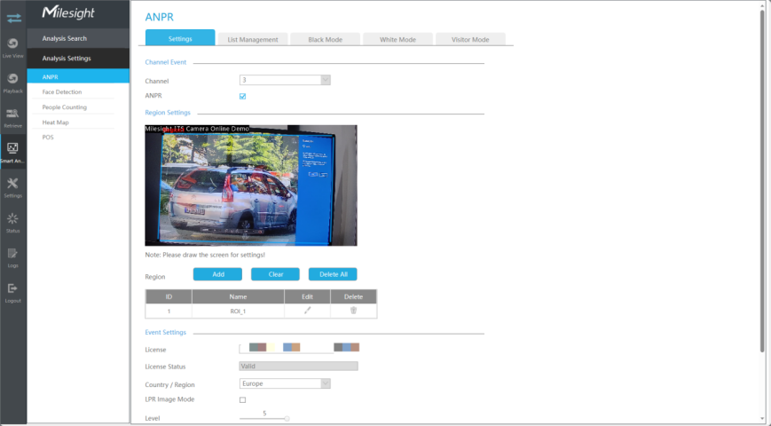

Troubleshooting common problems:
When the license plate is recognized, the ANPR Camera will transmit the recognition result data to the NVR. Usually, there are two reasons why NVR cannot receive LPR data.
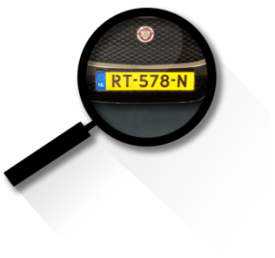
- The local monitor cannot display license plate information after turning on the target mode.
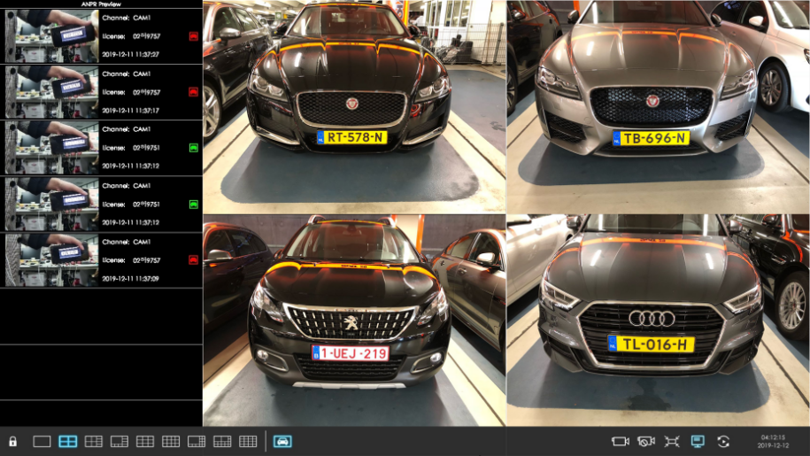
- ANPR Search cannot search for relevant license plate information.
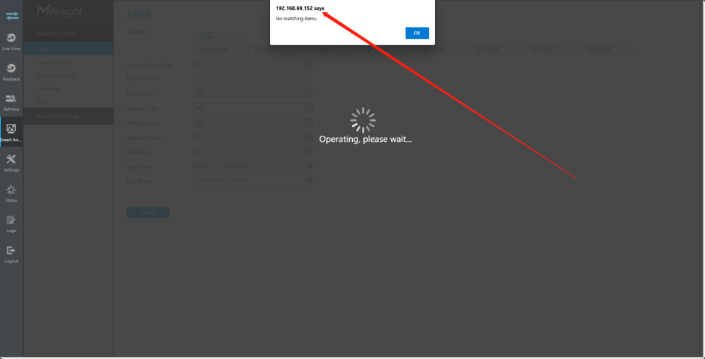
Common reasons why NVR cannot receive license plate data mainly include the following situations:

The LPR Message Post mode is not set correctly
LPR message post supports HTTP/TCP/RTSP three methods, but they cannot take effect at the same time.Only when set to TCP mode, the NVR can receive the license plate data sent by the ANPR Camera. Please set TCP as Post Type which is the default mode.
It can be set in Camera web page -> Traffic” -> “LPR” -> “General” -> “LPR Message Post Settings”.
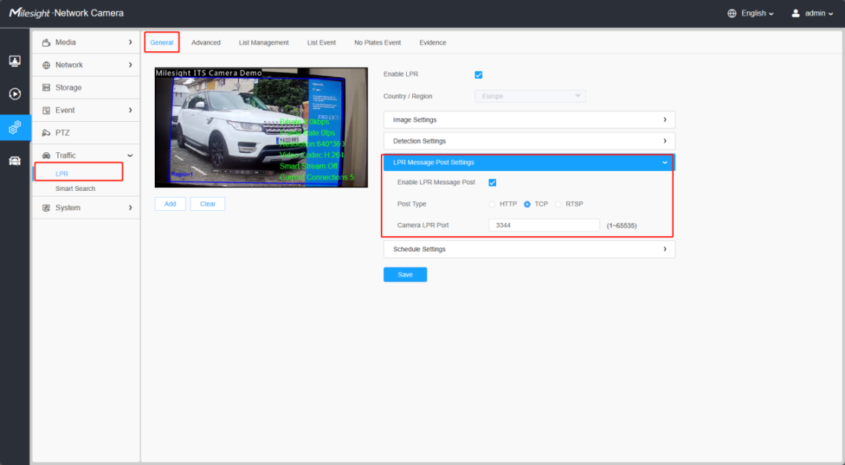
If you need Milesight NVR and third-party software to receive LPR data at the same time, it is recommended that you use TCP to transmit to Milesight NVR, and use HTTP notifications in list events to transmit license plate data to the third-party server.
Note：
1.The HTTP notification Post method is only supported on the TS series PE platform and the latest version T_61.8.0.3-XX-r7 camera, for example: TS2866-X4TPE;
2.Other models default to the get mode, and the notification only carries the license plate number.
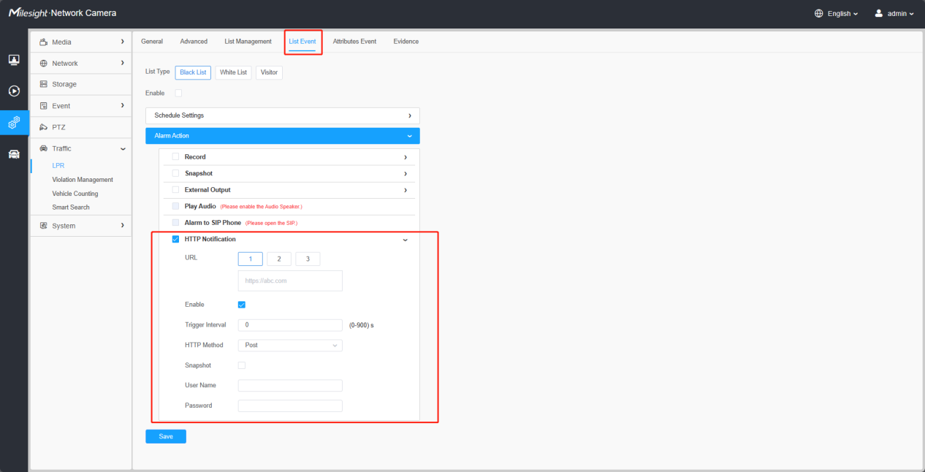

Network anomaly
Please ensure that the Milesight NVR and ANPR Camera network environment is not affected by firewalls, which may cause TCP connection abnormalities.
If the firewall is turned on, it may restrict ports during TCP transmission and block TCP connections on specific ports. Then, the TCP connection may not be able to communicate over that port. Or perform data packet inspection and filtering. If the firewall performs excessive inspection or misjudgment on TCP data packets, it may interfere with or prevent normal TCP transmission.

TCP connection limit
The TCP connections of the ANPR camera are limited to 5. When there are multiple back-end devices connected, the excess devices will not be able to receive data, you can try to change the Camera password and add it again. Or try to delete the ANPR Camera from other devices to verify the problem.
You can view information on the number of currently connected devices from the ANPR camera live view interface. Usually each Milesight back-end device will occupy 2 stream connections.
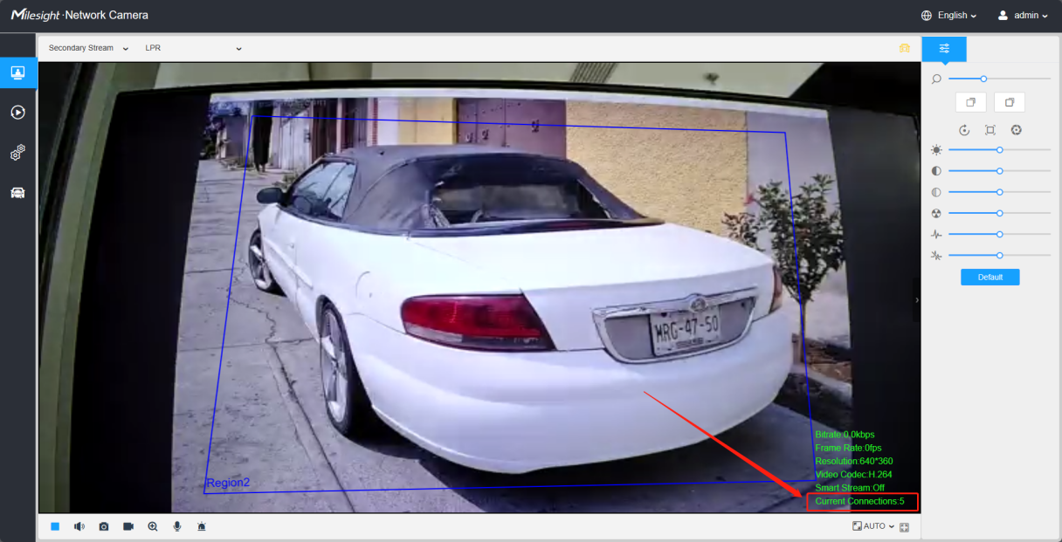

LPR data posting port is abnormal
Milesight NVR supports adding ANPR Cameras for management through public IP address. If you use public IP address to add and map multiple ANPR cameras at the same time, please make sure that the TCP port of each ANPR Camera has been mapped separately.
For example, when you need to add two ANPR cameras to the Milesight NVR for management through the public IP address, please make sure that the LPR post ports of the two cameras are properly mapped and that there is no port occupation.
The post port can be manually modified to ensure that the port is not occupied effectively.
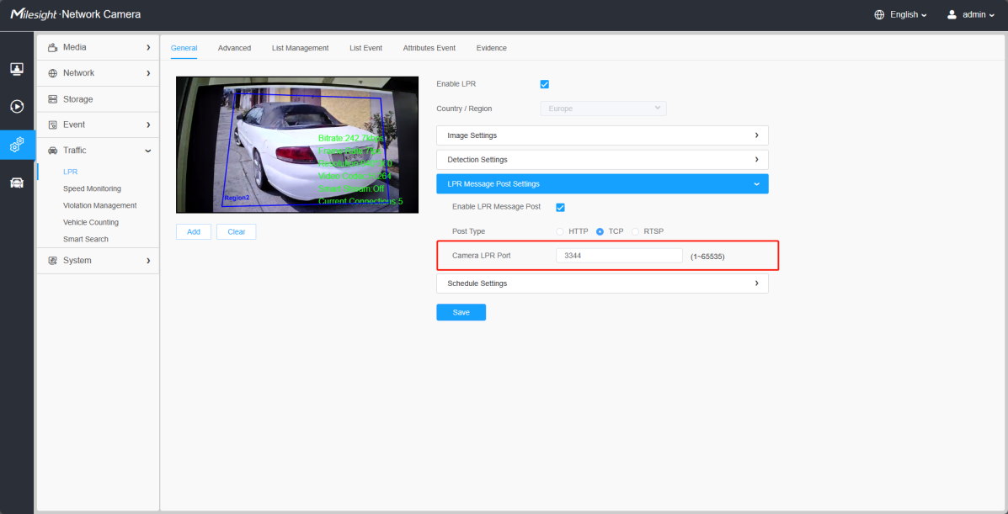

Version defects
In the previous old version, there were compatibility issues that caused abnormal data reception. It is recommended to update the existing Milesight NVR version to the latest version to detect the license plate reception.
Firmware Download|The Latest Innovation|Milesight

If normal reception of LPR messages cannot be restored after checking the above configuration, Please contact Milesight for technical support in time. Submit a ticket : Support (milesight.com)

-END-

